Supervised Machine Learning – Classification

Mental Health Problem In Tech Industry



CONTENT

1. Problem Statement
2. Introduction
3. Features Summary
4. Exploratory Data Analysis
5. Data Cleaning
6. Splitting Data
7. Transformation of Data
8. Fitting Different Model
9. Cross Validation and Parameter Tuning
10. Comparison Of Model
11. Feature Importance
12. Conclusion

PROBLEM STATEMENT:

* **Develop a Model that can predict whether a employee seek treatment or not**
* **Also Identify the key Features that lead to mental Health Problems in tech space.**

**Introduction**

* Nearly 86% of employees report improved work performance and lower rates of absenteeism after receiving treatment for depression, according to an April 2018 article in the Journal of Occupational and Environmental Medicine. This means big gains in retention and productivity for employers. By providing employees access to mental health benefits, the company can begin to create a culture of understanding and compassion at the tech company. And having employees who feel cared for and happy isn’t just good, it’s good business.
* Companies can use this model to know better about employee mental health issues and provide benefits for the needful employees, thus making efficient use of companies resources. This model can help in cutting off extra cost of providing mental health benefits for people who don't seek and use that money for other benefits of that employee. This will eventually increase employee satisfaction leading employee retention overall.

**Features Summary**

* This dataset is from a 2014 survey that measures attitudes towards mental health and frequency of mental health disorders in the tech workplace.
* **Timestamp: Tells us the time when the person is being surveyed.**
* **Age : age of the person**
* **Gender : Gender of the person (1 – Female 2 – Male 3 - Other)**
* **Country : Country of the Person.**
* **State**: If you live in the United States, which state or territory do you live in?
* **self_employed**: Are you self-employed?
* **family_history**: Do you have a family history of mental illness?
* **treatment**: Have you sought treatment for a mental health condition?
* **work_interfere**: If you have a mental health condition, do you feel that it interferes with your work?
* **no_employees**: How many employees does your company or organization have?
* **remote_work**: Do you work remotely (outside of an office) at least 50% of the time?
* **tech_company**: Is your employer primarily a tech company/organization?
* **benefits**: Does your employer provide mental health benefits?
* **care_options**: Do you know the options for mental health care your employer provides?
* **wellness_program**: Has your employer ever discussed mental health as part of an employee wellness program?
* **seek_help**: Does your employer provide resources to learn more about mental health issues and how to seek help?
* **anonymity**: Is your anonymity protected if you choose to take advantage of mental health or substance abuse treatment resources?
* **leave**: How easy is it for you to take medical leave for a mental health condition?
* **mental**health**consequence**: Do you think that discussing a mental health issue with your employer would have negative consequences?
* **phys**health**consequence**: Do you think that discussing a physical health issue with your employer would have negative consequences?
* **coworkers**: Would you be willing to discuss a mental health issue with your coworkers?
* **supervisor**: Would you be willing to discuss a mental health issue with your direct supervisor(s)?
* **mental**health**interview**: Would you bring up a mental health issue with a potential employer in an interview?
* **phys**health**interview**: Would you bring up a physical health issue with a potential employer in an interview?
* **mental**vs**physical**: Do you feel that your employer takes mental health as seriously as physical health?
* **obs_consequence**: Have you heard of or observed negative consequences for coworkers with mental health conditions in your workplace?
* **comments**: Any additional notes or comments

EXPLORATORY DATA ANALYSIS

# People who opt for Mental Treatment

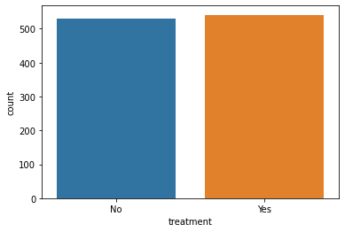

* Little more than 50% people are taking treatment , this is our target varible and there is no such class imbalance we are reday to go with this column.

# People taking mental health treament according to the Age

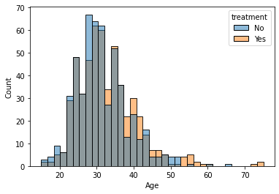

* Both the curve are merging so we can take any key insight from here.

# Is Self Employment plays role In Mental Health

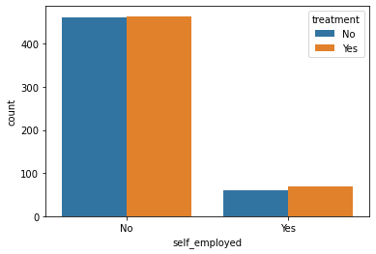

* More than 80% people(approx) are not self_employed. Despite being the large difference , people taking mental treatment are almost same. So it does not Matter whether the person is self_employed or not , person is taking mental help. Their is imbalance but the class distribution is same so no difference at all.

# Is your mental health affecting your workpower.

# D:\data sets\Mental Health Problem\download (3).png

# Almost 80% people feel that their mental health conditions affect their work sometimes,rarely and frequently. Mental health conditions sometimes become an interfere while working about 45%.

# D:\data sets\Mental Health Problem\download (4).png

# The plots prove that almost 80% want to get treatment. But it's surprising to know even mental health never has interfered at work, there is a little group that still want to get treatment before it become a job stress. It can be triggered by the requirements of the job do not match the capabilities, resources or needs of the worker If you are running a tech organization , you should consider providing resources for employees seeking treatment and it will help in boosting employee experience and will definitely increase their productivity.

# Family history of mental illness

# D:\data sets\Mental Health Problem\download (5).png

# Their are less than 40 % people who have family history of mental health problem.

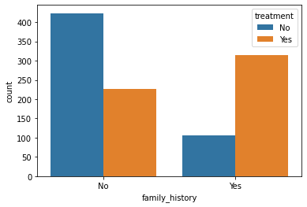

It clearly shows people who have mental health problems in their Family are more bound to take treatment in comparison of the people who dont have mental health problems in their family.

This will be an important feature.

# People doing remote work(more than 50% of their time)

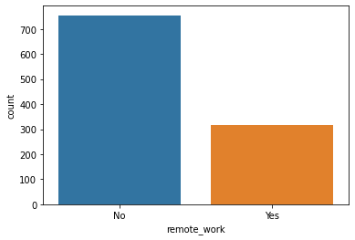

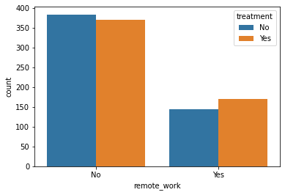

Doesn't matter remote work or not, almost 50% of people in both categories seek treatment. People in remote work are sligtly more in number who seek treatment. It might be due to lack of social interaction in remote mode.

# does employer provide mental health benefits

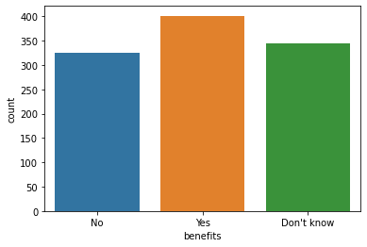

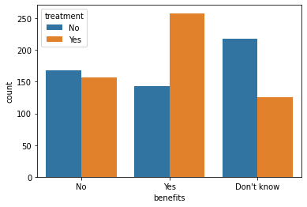

We see that around 38% of the respondents said that their employer provided them mental health benefits, whereas a significant number ( 32% ) of them didn't even know whether they were provided this benefit. Coming to the second graph,we see that for the people who YES said to mental health benefits, around 63% of them said that they were seeking medical help. So we can see the employer resources are utilized to a larger extent. Even if you think about the cost , you should definitely go for it because it is efficiently utilized by the employees. Surprisingly, the people who said NO for the mental health benefits provided by the company, close to 45% of them who want to seek mental health treatment.

# Mental healthcare options provided by Employer

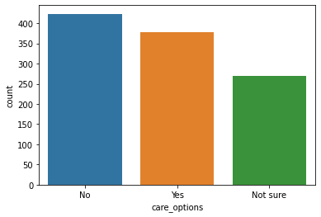

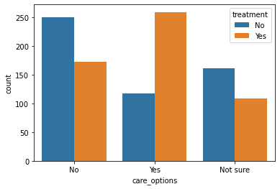

40% of employees are not provided any care options and 25% are not sure whether care options exist in company. We can see 60% of employees whos organization dont have care options are seeking treatment. These organizations needs to address this issue. People who have care options are actually seeking treatment, this can validate our claim to have care options.

# Number of Employees in the Company¶

# D:\data sets\Mental Health Problem\download (13).png

# D:\data sets\Mental Health Problem\download (14).png

# Smaller companies are providing less benefits than the larger one. Size of the is not affecting whether people are seeking mental help or not.

# Does Mental Health comes in your employee wellness program

# D:\data sets\Mental Health Problem\download (15).png

# D:\data sets\Mental Health Problem\download (16).png

# 70% employers haven't discussed mental health as a employee wellness program. Around 50% People who don't know about the program are seeking help. This means organizations should explain the mental health benefits provided by the company Companies should include mental health in the employee wellness program.This shouldn't be overlooked

# Does employer provide ways to seek help in case of Mental Health

# D:\data sets\Mental Health Problem\download (17).png

# D:\data sets\Mental Health Problem\download (18).png

# More Than 51% respondents said they have not been provided ways for seeking in case of meantal health by the employers. It can be clearly seen that the places where they provided help , more percentage of people took treatment.

# Is your Identity be remained anonymous if you use resources

# D:\data sets\Mental Health Problem\download (19).pngD:\data sets\Mental Health Problem\download (20).png

# Almost 65% of the respondents have no idea about it. Companies should create a safe environment for people to feel safe to share their problems. We can establish the fact that people who think their anonymity is protected are more willing to seek treatment.

# How easy it for you take Medical Leave for a Mental Health Condition

# D:\data sets\Mental Health Problem\download (21).pngD:\data sets\Mental Health Problem\download (22).png

1. 45% have no idea about it.
2. Places where Leave is Difficult to get they are more into Treatment.
3. Important feature for the Model.

# Discussing Mental Health with the coworker

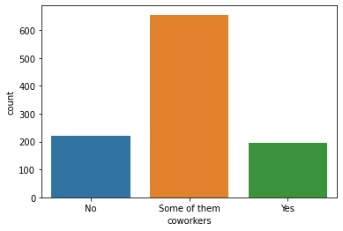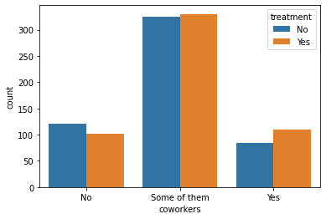

Good sign that most people have atleast some people(coworkers) to talk to about the mental health issues.

# Is Mental Health Taken Seriously ?

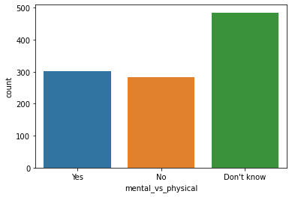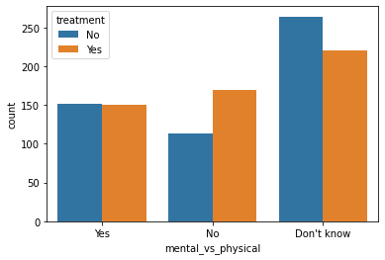

Places where Mental health is not treated as same as Physical Health , people are more inclined for Treatment.

# Does Colleagues Have negative consequences about Mental Health

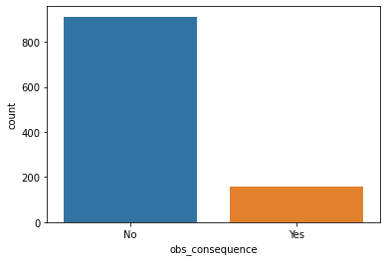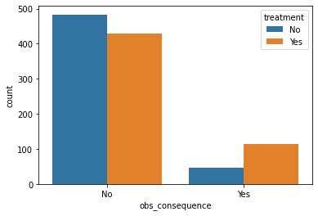

**Splitting Data**

* Data splits into training dataset and testing dataset.
* Training dataset is used to fit the machine learning model.
* Test dataset is used to evaluate the fit machine learning model.
* Here 85% of the data taken as training dataset and remaining 15% of dataset used for testing purpose.

# Data Preprocessing

* Null Values treatment.
* Duplicate Values treatment.
* Label Encoding
* Ordinal Encoding

**Transformation of Data**

* **T**o scale data into a uniform format that would allow us to utilize the data in a better way.
* For performing fitting and applying different algorithms to it.
* The basic goal was to enforce a level of consistency or uniformity to dataset.

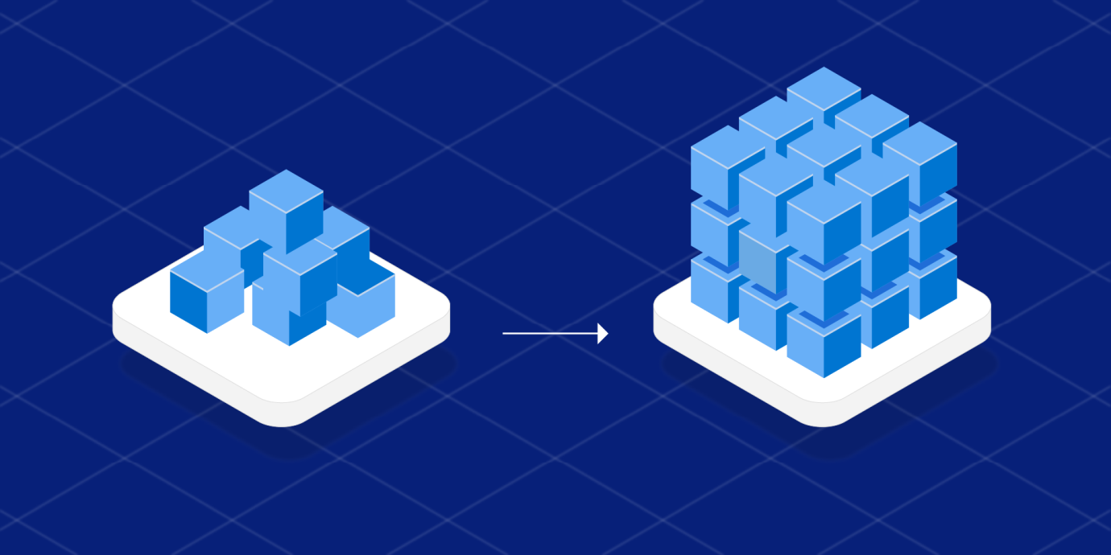

Fitting Different Model

* Following classifiers are used for predicting whether employee seek mental treatment or not:
* Logistic Regression
* Decision Tree Classifier
* Random Forest Classifier
* Support Vector Machine
* Gradient Boosting
* Xgboost
* Adaboost

Cross Validation & Parameter Tuning

* It is a resampling procedure used to evaluate machine learning models on a limited data sample.
* Basically,Cross validation is a technique using which Model is evaluated on the Dataset on which it is not trained that is it can be a test data or can be another set as per availability .
* Tuning the hyperparameters of respective algorithms is necessary for getting better accuracy and to avoid overfitting.

DIFFERENT MODELS

1. **Logistic Regression**

* Logistic Regression is a machine learning algorithm for classification problem.
* It is a predictive analysis algorithm and based on the concept of probability.
* It is most useful for understanding the influence of several independent variables on a single output variable.



1. **Decision Tree Classifier**

* Given a data of attributes together with its classes, a decision tree produces tree produces a sequence of rules that can be used to classify the data.
* Decision Tree is simple to understand and visualize , and can handle both numerical and categorical data.



1. **Random Forest Classifier**

* Random Forest is a classifier that contains a number of decision trees on various subsets of the given dataset and takes the average to improve the predictive accuracy of the dataset.
* The sub sample size is always the same as the original input sample size but the samples drawn with replacement.

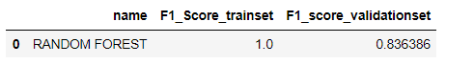

1. **Support Vector Machine**

* SVM is a representation of the training data as points in space separated into categories by a clear gap that is as wide as possible.
* The objective of the SVM algorithm is to find a hyperplane in an N-dimensional space that distinctly classifies the data points.

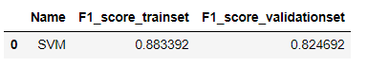

1. **Gradient Boosting**

* It is a group of ML algorithms that combine many weak learning models together to create a strong predictive model.
* It is a sequential Ensemble learning technique where the performance of the model improves over iterations.



1. **XG Boosting**

* XG boost is a decision tree based ensemble ML algorithm that uses a gradient bossting framework.
* It is a perfect combination of software and hardware optimization techniques to yield superior results using less computing resources in the shortest amount of time.

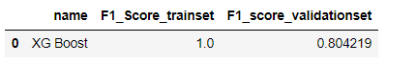

Comparison of Model

After comparing f-1 score of all the models, the f-1 score of Gradient Boosting and Random Forest comes out to be highest.

After doing the Final analysis with the test set we choose the Gradient Boosting Algorithm as it is providing the highest f-1 Score of 87 %.

**FEATURE IMPORTANCE**

* Feature selection is the process of reducing the number of features when developing a predictive model.
* It is desirable to reduce the number of input variables to both reduce the computational cost of the modelling and , in some cases , to improve the performance of the model.

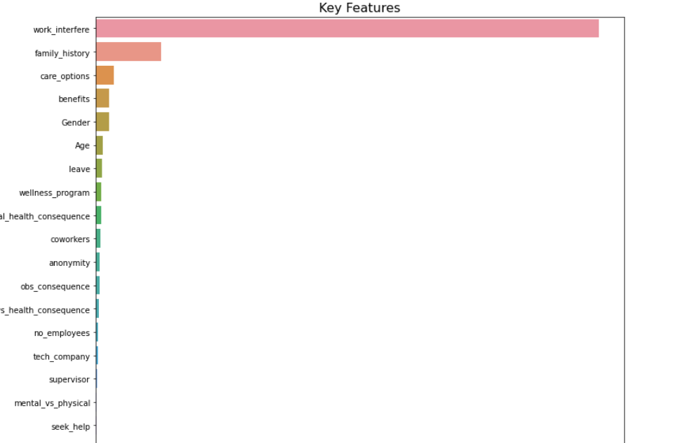

**CONCLUSION**

1. Work interference has the largest contribution.
2. Whether the employee's mental health issues interfering with the work is the thing that the company should ask for its employees.
3. Family history and care options(programs and benfits) provided by company is also influential in employees who want to get treatment.
4. For all the remaining features,there has been a little contribution. noticing/knowing some of these features beforehand can even help support an individual who may be experiencing a mental health issues and and connect them with the appropriate employee resources.